Status: Draft (Collaborative)
Owner: Tony
Last Updated: 1/19/2026

Use Cases - Call 5 Voter Engagement

Overview 3
Actors 3
Voter 3
Civic Group Member 4
Candidate 4
Voter Engagement App 4
Administrator (Optional / Future) 4
Voter Questions - Core Use Cases 4
UC-VQ-1: Submit Question 4
UC-VQ-2: Candidate Response 4
Call Five People — Core Use Cases 5
UC-CF-1: A Civic Group Member Creates a Civic Group 5
UC-CF-2: A Civic Group Member Invites People to Join a Civic Group 5
UC-CF-3: Accept an Invitation and Join 5
UC-CF-4: Prevent Multiple Civic Group Memberships 5
UC-CF-5: Grow Beyond Five Members 5
UC-CF-6: Track Who Invited Whom 5
UC-CF-7: Viewing Civic Group Membership 5
UC-CF-8: Political Issues List 6
UC-CF-9: Group Chat 6
UC-CF-10: Active Members Group List Access 6
UC-CF-11: Google Id For Login 6
Future Questions for Discussion 6
Q-1 Do Voters Need to Login? 6

Date | Description
1/19/2026 | Changed Civic Unit to Civic Group
1/19/2026 | Add City label to Civic Group
1/19/2026 | Added UC-CF-8, UC-CF-9, UC-CF-10, UC-CF-11

Overview
This document captures the primary use cases for the Voter Engagement App. Its purpose is to provide a shared understanding of how voters, candidates, and the system interact, independent of specific implementation details.
The use cases described here focus on user intent and system behavior, not UI design, technical architecture, or policy outcomes. They are meant to guide development, surface assumptions, and support discussion among team members and collaborators.
These use cases are intended to directly inform the system’s data model by identifying the core entities, relationships, and constraints required to support voter interactions and Civic Unit formation. They provide the foundation for subsequent data modeling and design walkthroughs.
This is a living document. Feedback is welcome via comments, especially around clarity, realism, and missing scenarios.

Actors

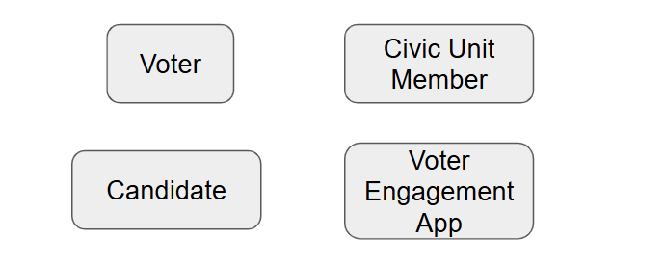
This diagram is intended to support discussion, not to define final roles or system boundaries.

Voter
An individual who uses the application to submit a question or comment intended for a political candidate. The voter provides basic identifying information and the content of their inquiry. The voter’s primary goal is to express a concern, ask a question, or seek clarification related to a candidate’s campaign or public positions.

Civic Group Member
An individual who belongs to a Civic Group within the Call Five People feature. A Civic Group Member may invite others to join the unit, accept invitations, and view unit membership. A Civic Group Member may also be a Voter, but Civic Group membership is not required to submit a question to a candidate.

Candidate
A political candidate who is the intended recipient of voter questions. In the current implementation, candidate responses are generated by the system based on candidate-specific context rather than being authored directly by the candidate. The candidate actor represents the perspective and policy stance that informs the response.

Voter Engagement App
The system that facilitates the interaction between voters and candidates. The application collects voter input, applies candidate-specific context, generates a response, and presents that response back to the voter. The system also manages basic validation, logging, and configuration necessary to support the interaction.

Administrator (Optional / Future)
An individual responsible for managing system configuration, candidate context, and operational settings. This role may include reviewing logs, updating candidate information, and controlling feature availability. Administrative capabilities may expand as the system evolves.

Voter Questions - Core Use Cases

UC-VQ-1: Submit Question
A voter provides basic identifying information (name, voter ID, address, email) and submits a question or comment intended for a specific political candidate. The system validates required fields and records the submission.

UC-VQ-2: Candidate Response
After a question is submitted, the system generates a response based on candidate-specific context and presents it to the voter. The response represents the candidate’s stated positions and tone, not a direct reply from the candidate.

Call Five People — Core Use Cases
The Call Five People feature extends the Voter Engagement App by enabling voters to organize into small, trust-based Civic Groups. Participation in Call Five People is not required to submit questions to candidates.

UC-CF-1: A Civic Group Member Creates a Civic Group
A Civic Group Member enters their name, address, voter ID, and email and creates a new Civic Group, becoming its first member. City name of founding member becomes city name of the new Civic Group.

UC-CF-2: A Civic Group Member Invites People to Join a Civic Group
A member of a Civic Group invites up to five people by email, direct message, or phone using a unique invite link associated with the unit.

UC-CF-3: Accept an Invitation and Join
An invited person opens the invite link, provides their name, address, voter ID, email (and optional phone), and becomes a Civic Group Member of the inviting Civic Group.

UC-CF-4: Prevent Multiple Civic Group Memberships
If a person who is already a member of a Civic Group attempts to join another one, the system prevents it and explains why.

UC-CF-5: Grow Beyond Five Members
A Civic Group that already has five members may continue to invite and add additional members, even though five is the recommended size.

UC-CF-6: Track Who Invited Whom
The system records which member sent each invitation and whether it was accepted, allowing the network’s growth path to be understood.

UC-CF-7: Viewing Civic Group Membership
A Civic Group member can see the list of people in their Civic Group and basic status information (active members only).

UC-CF-8: Political Issues List
A Civic Groups maintain a list of political issues that are important to the group

UC-CF-9: Group Chat
A Civic Group Members use the voter engagement application as a group chat to communicate with each other

UC-CF-10: Active Members Group List Access
A member can see the list of people in their Civic Group and basic status information (active members only).

UC-CF-11: Google Id For Login
Voters log into the voter engagement application using their Google id for authentication

Future Questions for Discussion

Q-1 Do Voters Need to Login?

